Name: Muhammad Sherjeel Akhtar

Roll No: 20p-0101

Section: 5B

Task: 02

Task 1:

Part 1:



Answer:

First of all open the Cisco_Packet_Tracer by searching it in the search bar.

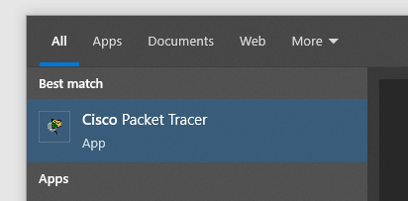

Then in the Cisco Packet Tracer go to the end devices and select Two computers from there.

Computer 1:

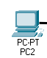

Computer 2:



In step three, connect both the PC’s using a wire.

Copper Cross Over wire will be used in this case.

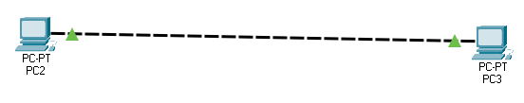

Open first computer, go to the Ip configuration and assign the Ip **192.168.1.2**

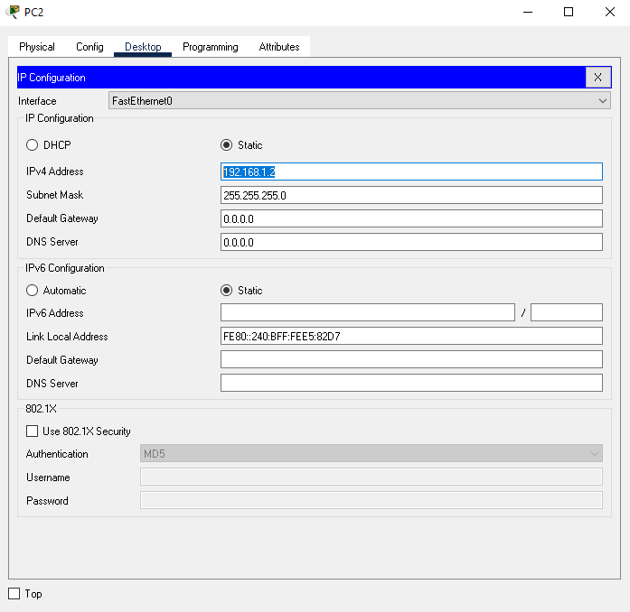

Open second computer, go to the Ip configuration and assign the Ip **192.168.1.3**

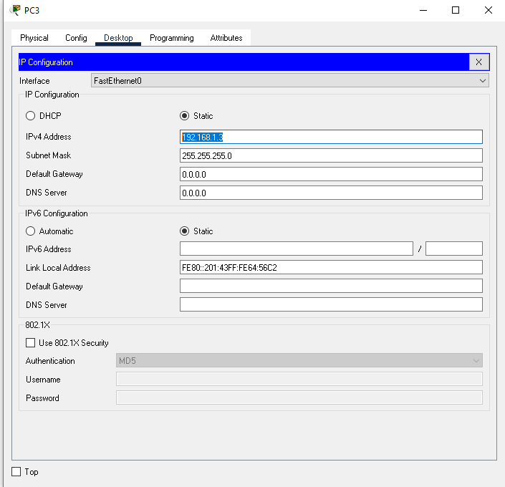

Step 4:

Open the command prompt on the first computer and write a command **ping 192.168.1.3.**

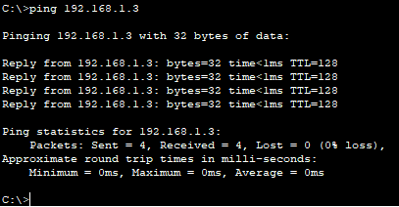

**You will see a successful ping between both computers.**

**Part 2:**



**Answer:**

Step 1:

First of all just like the previous work, setup two PC’s on the screen.

Computer 1:



Computer 2:



Step 2:

Connect both of the Pc’s using a crossover wire.

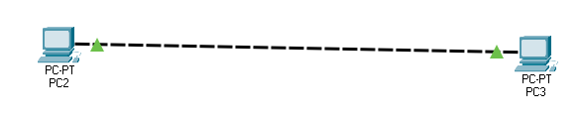

Step 3:

Assign the Ip Addresses and Subnet Masks to both of the PC’s.

Computer 1: **IPv4: 192.168.1.1 Subnet mask: 255.255.255.0**



Computer 2: **IPv4: 192.168.2.1 Subnet mask: 255.255.255.0**



Step 4:

Do a ping test by using first computer on the Ip of second Computer.

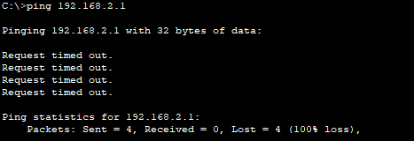

The ping result in the above screenshot. We are pinging from the Ip of first computer to the Ip of the second computer. The This failure in result is because of the Ip Address and the Subnet Masks assigned to both computers. In case of using different Ip Addresses, you can the timeout when pinging from one computer to the other. The main reason of this failure is the subnet mask activation. The subnet masks active in this case is **255.255.255.0.** Due to which all the four figures of Ip of both the computers are working. Due to which there is a big difference in the third last figure of both Ip’s 192.168.**1**.1 and 192.168.**2**.1. Due to subnet mask these two figures **1** and **2** are active and will result in the failure of the ping.

**Part 3:**



**Answer:**

Step 1:

Use two computers and put them on the screen in Cisco Packet Tracer.

Computer 1:



Computer 2:



Step 2:   
Connect both of the computers using a crossover wire.



Step 3:

Assign the following Ip addresses and subnet masks to both of the computers.

Computer 1: IPv4: **192.168.1.1 Subnet mask: 255.255.0.0**



Computer 2: IPv4: **192.168.2.1 Subnet mask: 255.255.0.0**



Step 4:

Do a ping test from computer 1 to computer 2 in command prompt.

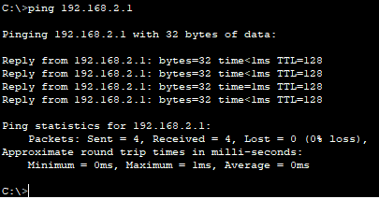

**You can see the successful ping test in the above screenshot.**

**Task 2:**

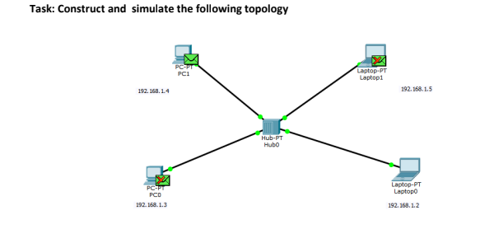

**Answer:**

Step 1:

First of put 4 computers on the screen. 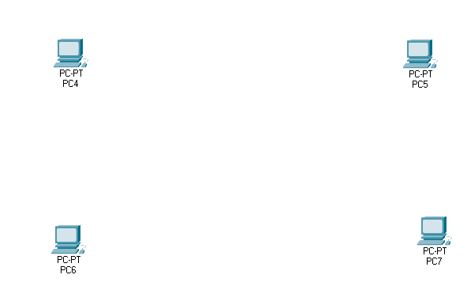

Step 2:

Place an Hub in the center of four computers.

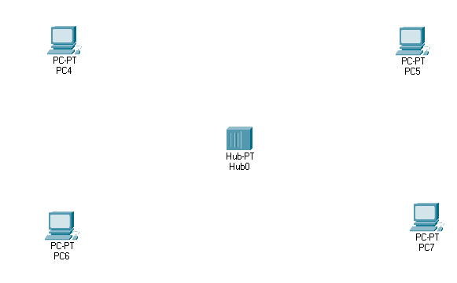

Step 3:

Connect all four computers with the Hub using a straight copper wire.

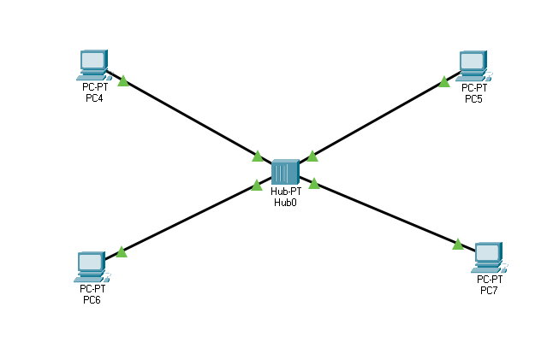Step 4:

Assign the following Ips to the 4 computers.

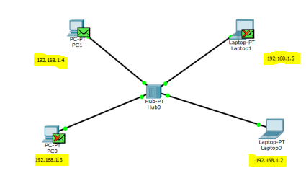

Step 5:

Now select the simulation button from the bottom right corner.



Step 5:

Now select the packet from the top and click it on the first computer and the second computer from the top in order to confirm the sender and receiver computers.

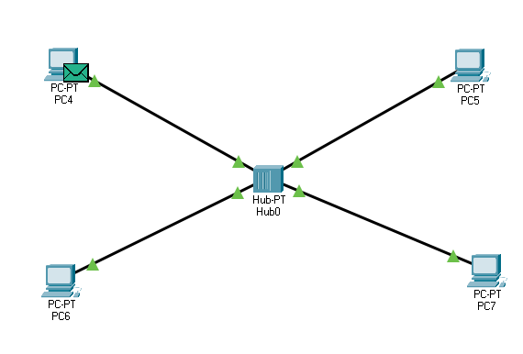

Step 6:

Packet will move from sender to hub.

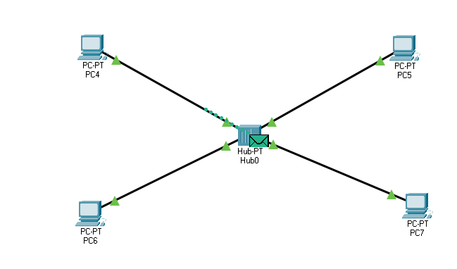

Step 7:

Packet will move from Hub to Receiver computer.

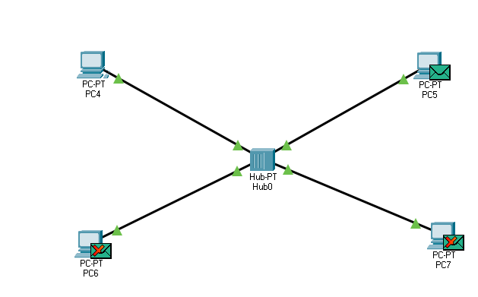

Step 8:   
After receiving the message the receiver will send an acknowledgement back to the hub.

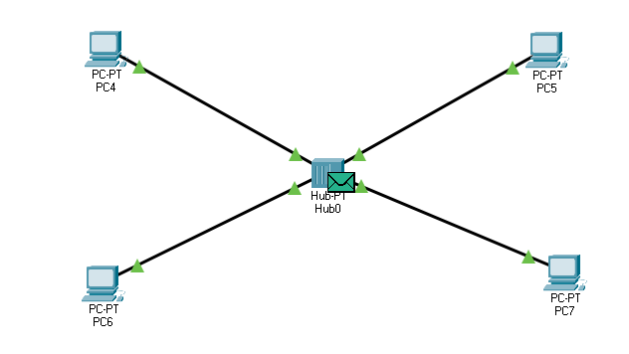

Step 9:

Hub will send the acknowledgement message back to the sender computer.

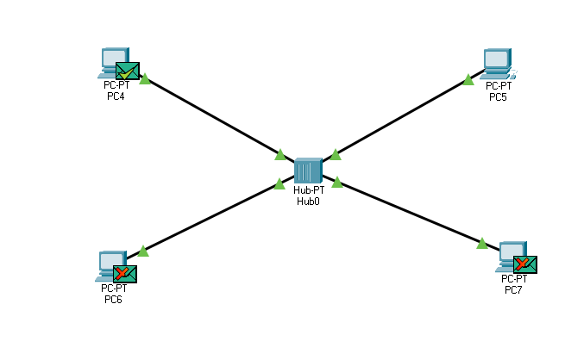

**This was the working of Hub and transfer of the packets between computers.**

**Task 3:**